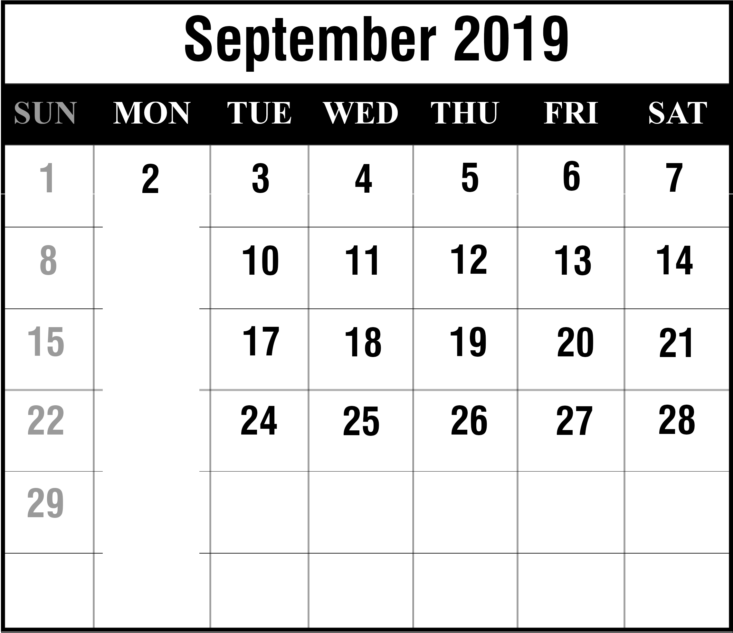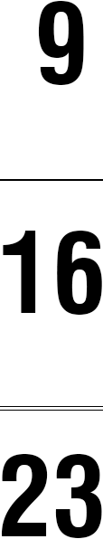

Labor Day

Autumnal Equinox

Rosh Hashanah

