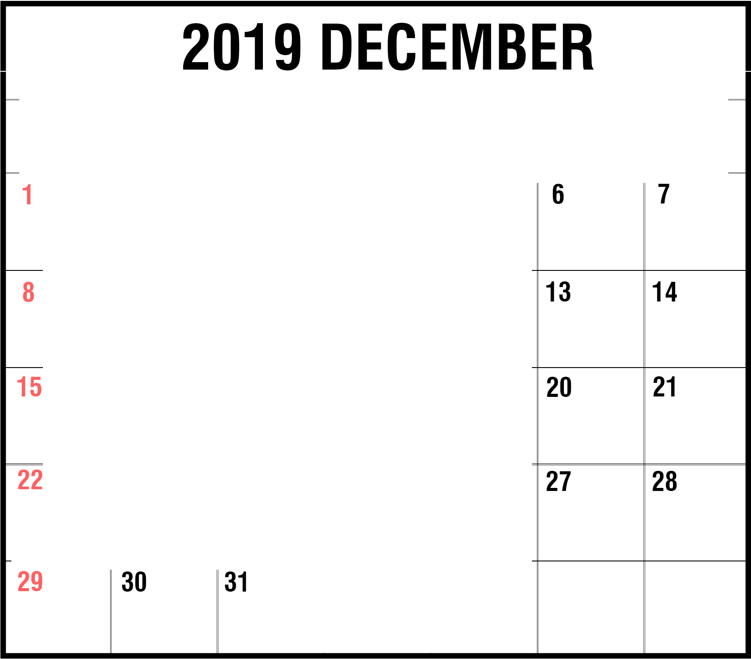SUN
NOTES

Hanukkah Begins

ON TUE ED THU FRI SAT

Christmas Day Kwanzaa Begins

New Year's Eve

