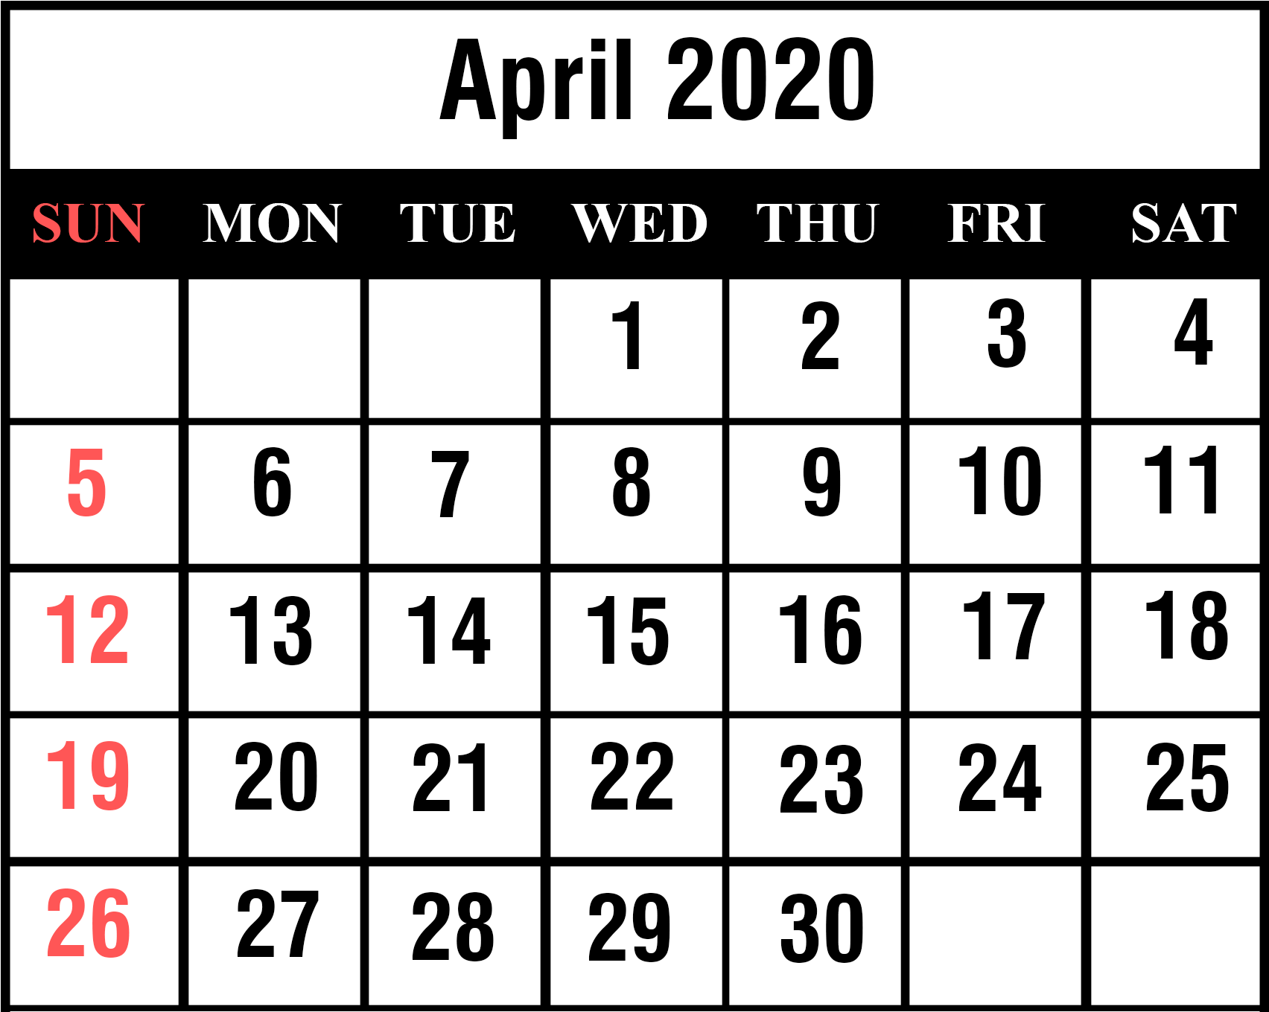1st: April Fool's Day 9th: Passover 12th: Easter
24th: Ramdan Begins
22nd: Admin Assistants Day

