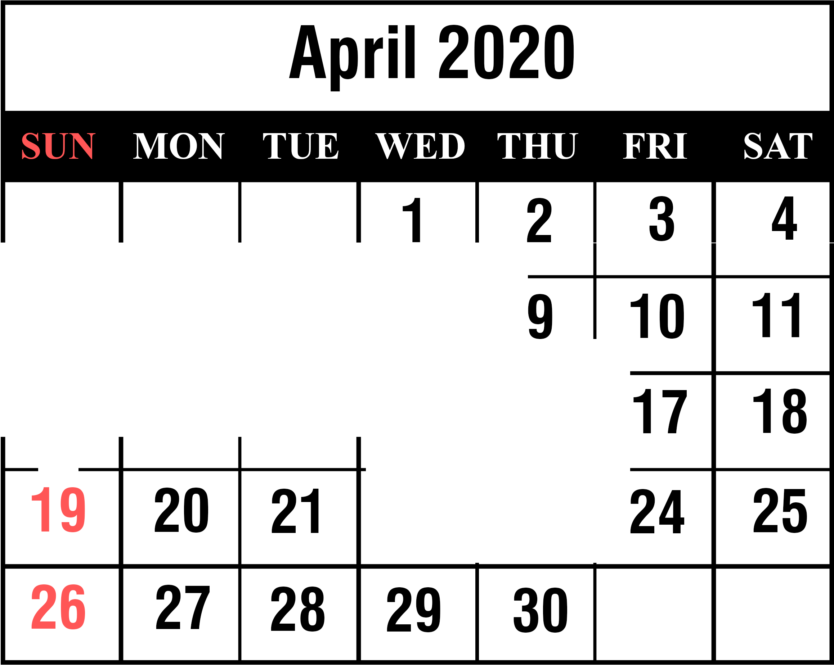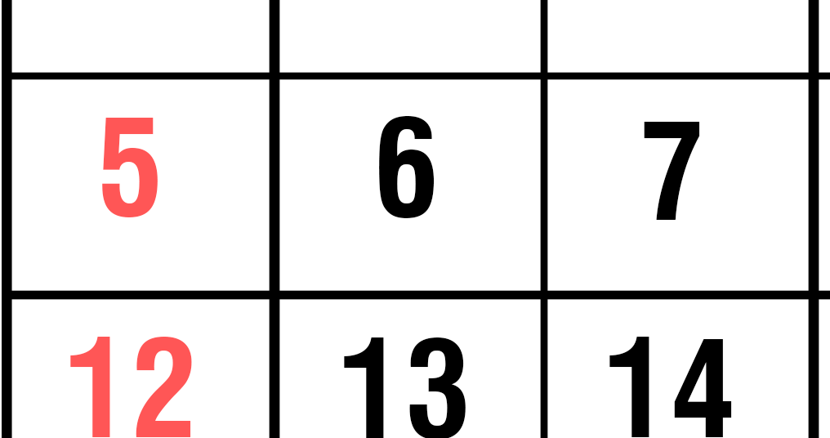

April Fool's Day

Passover

Easter

Admin Assistants Day Ramdan Begins

